BULLETIN FOR ONLINE & IN-PERSON WORSHIP
May 9, 2021

St. George’s Episcopal Memorial Church
601 N 4th Street / PO Box 1241
Bismarck, North Dakota 58502-1241
701-223-1942
stgeorges-bismarck.org

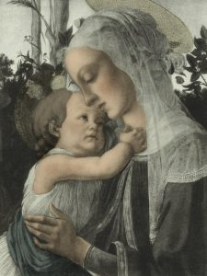
St. George’s Mission Statement
We are called by God:
--to make Christ the center of our lives
--to support one another in our journey with Christ
--to serve the world in Christ’s Name
HOLY EUCHARIST
THE SIXTH SUNDAY OF EASTER
MAY 9, 2021, RITE II, 10 AM

THE LITURGY OF THE WORD OF GOD

Prelude Organ/Piano Solo

Introit Choir
“Celtic Alleluia” (choir a cappella)

Opening Hymn #291 Choir & Congregation
“We plow the field and scatter” (vs 1-3) Wir Pflugen

The Salutation BCP p. 355

The people standing, the Celebrant says

Celebrant Alleluia. Christ is risen.
People The Lord is risen indeed. Alleluia

The Collect for Purity BCP p. 355

The Celebrant may say

Almighty God, to you all hearts are open, all desires known, and from you no secrets are hid: Cleanse the thoughts of our hearts by the inspiration of your Holy Spirit, that we may perfectly love you, and worthily magnify your holy Name; through Christ our Lord. Amen.

The Gloria #S-278 Choir & Congregation

BCP p. 356
All stand and sing

Glory to God in the highest,
and peace to his people on earth.
Lord God, heavenly King,
almighty God and Father,
we worship you, we give you thanks,
we praise you for your glory.
Lord Jesus Christ, only Son of the Father,
Lord God, Lamb of God,
you take away the sin of the world:
have mercy on us;
you are seated at the right hand of the Father:
receive our prayer.
For you alone are the Holy One,
you alone are the Lord,
you alone are the Most High,
Jesus Christ, with the Holy Spirit,
in the glory of God the Father. Amen.

The Collect of the Day BCP p. 225

The Celebrant says to the people

The Lord be with you.
People And also with you.
Celebrant Let us pray.

The Celebrant says the Collect.

O God, you have prepared for those who love you such good things as surpass our understanding: Pour into our hearts such love towards you, that we, loving you in all things and above all things, may obtain your promises, which exceed all that we can desire; through Jesus Christ our Lord, who lives and reigns with you and the Holy Spirit, one God, for ever and ever. Amen.

First Lesson Acts 10:44-48

While Peter was still speaking, the Holy Spirit fell upon all who heard the word. The circumcised believers who had come with Peter were astounded that the gift of the Holy Spirit had been poured out even on the Gentiles, for they heard them speaking in tongues and extolling God. Then Peter said, "Can anyone withhold the water for baptizing these people who have received the Holy Spirit just as we have?" So he ordered them to be baptized in the name of Jesus Christ. Then they invited him to stay for several days.

After the Reading, the Reader may say

The Word of the Lord.
People Thanks be to God.

Psalm 98 BCP p. 727
1 Sing to the Lord a new song, *
for he has done marvelous things.
2 With his right hand and his holy arm *
has he won for himself the victory.
3 The Lord has made known his victory; *
his righteousness has he openly shown in the sight of the nations.
4 He remembers his mercy and faithfulness to the house of Israel, *
and all the ends of the earth have seen the victory of our God.
5 Shout with joy to the Lord, all you lands; *
lift up your voice, rejoice, and sing.
6 Sing to the Lord with the harp, *
with the harp and the voice of song.
7 With trumpets and the sound of the horn *
shout with joy before the King, the Lord.
8 Let the sea make a noise and all that is in it, *
the lands and those who dwell therein.
9 Let the rivers clap their hands, *
and let the hills ring out with joy before the Lord,
when he comes to judge the earth.
10 In righteousness shall he judge the world *
and the peoples with equity.

Second Lesson 1 John 5:1-6

Everyone who believes that Jesus is the Christ has been born of God, and everyone who loves the parent loves the child. By this we know that we love the children of God, when we love God and obey his commandments. For the love of God is this, that we obey his commandments. And his commandments are not burdensome, for whatever is born of God conquers the world. And this is the victory that conquers the world, our faith. Who is it that conquers the world but the one who believes that Jesus is the Son of God?

This is the one who came by water and blood, Jesus Christ, not with the water only but with the water and the blood. And the Spirit is the one that testifies, for the Spirit is the truth.

After the Reading, the Reader may say

The Word of the Lord.
People Thanks be to God.

Sequence Hymn #601 G&P Choir & Congregation
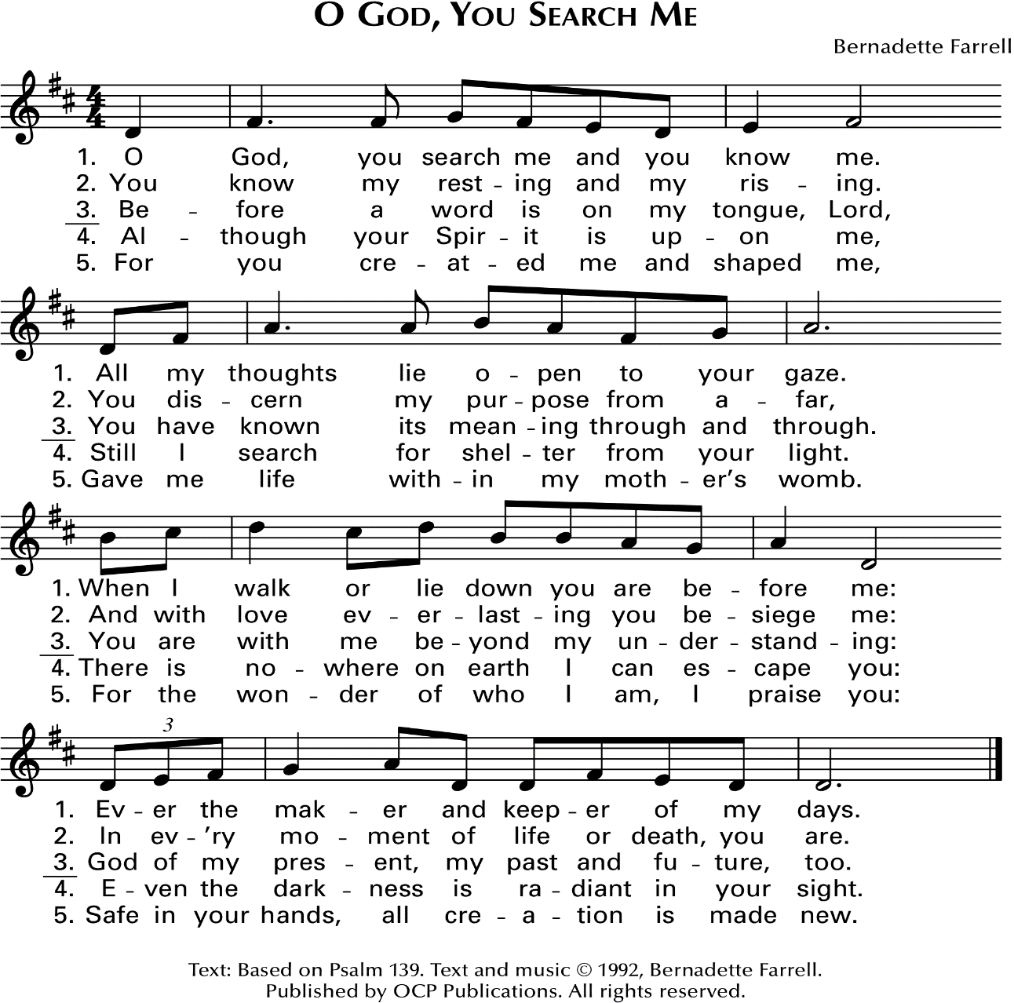
“O God, you search me” (vs 1-3) Farrell
Then, all standing, the Deacon or a Priest reads the Gospel, first saying

The Holy Gospel of our Lord Jesus Christ according to John.

People Glory to you, Lord Christ.

The Gospel John 15:9-17

Jesus said to his disciples, “As the Father has loved me, so I have loved you; abide in my love. If you keep my commandments, you will abide in my love, just as I have kept my Father’s commandments and abide in his love. I have said these things to you so that my joy may be in you, and that your joy may be complete.

“This is my commandment, that you love one another as I have loved you. No one has greater love than this, to lay down one’s life for one’s friends. You are my friends if you do what I command you. I do not call you servants any longer, because the servant does not know what the master is doing; but I have called you friends, because I have made known to you everything that I have heard from my Father. You did not choose me but I chose you. And I appointed you to go and bear fruit, fruit that will last, so that the Father will give you whatever you ask him in my name. I am giving you these commands so that you may love one another.”

After the Gospel, the Reader says

The Gospel of the Lord.
People Praise to you, Lord Christ.

The Sermon The Rev’d Canon Hal Weidman

The Nicene Creed BCP p. 358

We believe in one God,
the Father, the Almighty,
maker of heaven and earth,
of all that is, seen and unseen.
We believe in one Lord, Jesus Christ,
the only Son of God,
eternally begotten of the Father,
God from God, Light from Light,
true God from true God,
begotten, not made,
of one Being with the Father.
Through him all things were made.

For us and for our salvation
he came down from heaven:
by the power of the Holy Spirit
he became incarnate from the Virgin Mary,
and was made man.
For our sake he was crucified under Pontius Pilate;
he suffered death and was buried.
On the third day he rose again
in accordance with the Scriptures;
he ascended into heaven
and is seated at the right hand of the Father.

He will come again in glory to judge the living and the dead,
and his kingdom will have no end.

We believe in the Holy Spirit, the Lord, the giver of life,
who proceeds from the Father and the Son.
With the Father and the Son he is worshiped and glorified.
He has spoken through the Prophets.
We believe in one holy catholic and apostolic Church.
We acknowledge one baptism for the forgiveness of sins.
We look for the resurrection of the dead,
and the life of the world to come. Amen.

Prayers of The People, Form III BCP p. 387

The Leader and People pray responsively

Father, we pray for your holy Catholic Church;
That we all may be one.

Grant that every member of the Church may truly and
humbly serve you;
That your Name may be glorified by all people.

We pray for all bishops, priests, and deacons;
That they may be faithful ministers of your Word and
Sacraments.

We pray for all who govern and hold authority in the nations
of the world;
That there may be justice and peace on the earth.

Give us grace to do your will in all that we undertake;
That our works may find favor in your sight.

Have compassion on those who suffer from any grief or trouble;
That they may be delivered from their distress.

Give to the departed eternal rest.
Let light perpetual shine upon them.

We praise you for your saints who have entered into joy;
May we also come to share in your heavenly kingdom.

Let us pray for our own needs and those of others.

Silence

The People may add their own petitions.

The Celebrant adds a concluding Collect.

Almighty God, to whom our needs are known before we ask:
Help us to ask only what accords with your will; and those
good things which we dare not, or in our blindness cannot
ask, grant us for the sake of your Son Jesus Christ our Lord.
Amen.

The Confession BCP p. 360

We pray to you also for the forgiveness of our sins.

Silence may be kept.

Leader and People

Have mercy upon us, most merciful Father;
in your compassion forgive us our sins,
known and unknown,
things done and left undone;
and so uphold us by your Spirit
that we may live and serve you in newness of life,
to the honor and glory of your Name;
through Jesus Christ our Lord. Amen.

The Absolution BCP p. 360

The Bishop, when present, or the Priest, stands and says

Almighty God have mercy on you, forgive you all your sins through our Lord Jesus Christ, strengthen you in all goodness, and by the power of the Holy Spirit keep you in eternal life. Amen.

The Peace BCP p. 360

All stand. The Celebrant says to the people

The Peace of the Lord be always with you.
People And also with you.

Then the Ministers and People may greet one another in the name of the Lord.

Announcements

Offertory Choir
“Lover of Us All” Dan Schutte

THE LITURGY OF HOLY COMMUNION

The Great Thanksgiving
Eucharistic Prayer D BCP p. 372
The people remain standing. The Celebrant, whether bishop or priest, faces them and sings or says

 | The Lord be with you.
People | And also with you.
Celebrant | Lift up your hearts.
People | We lift them to the Lord.
Celebrant | Let us give thanks to the Lord our God.
People | It is right to give him thanks and praise.
Then, facing the Holy Table, the Celebrant proceeds
It truly right to glorify you, Father, and to give you thanks;
for you alone are God, living and true, dwelling in light
inaccessible from before time and for ever.

Fountain of life and source of all goodness, you made all
things and fill them with your blessing; you created them to
rejoice in the splendor of your radiance.

Countless throngs of angels stand before you to serve you
night and day; and, beholding the glory of your presence,
they offer you unceasing praise. Joining with them, and
giving voice to every creature under heaven, we acclaim you,
and glorify your Name, as we sing (say),

Celebrant and People

The Sanctus #S-124 Choir & Congregation
BCP p. 373
Holy, Holy, Holy Lord, God of power and might, heaven and earth are full of your glory. Hosanna in the highest. Blessed is he who comes in the name of the Lord. Hosanna in the highest.

The people stand or kneel as they are able.

Then the Celebrant continues

We acclaim you, holy Lord, glorious in power. Your mighty works reveal your wisdom and love. You formed us in your own image, giving the whole world into our care, so that, in obedience to you, our Creator, we might rule and serve all your creatures. When our disobedience took us far from you,
you did not abandon us to the power of death. In your mercy you came to our help, so that in seeking you we might find you. Again and again you called us into covenant with you, and through the prophets you taught us to hope for salvation.

Father, you loved the world so much that in the fullness of time you sent your only Son to be our Savior. Incarnate by the Holy Spirit, born of the Virgin Mary, he lived as one of us, yet without sin. To the poor he proclaimed the good news of salvation; to prisoners, freedom; to the sorrowful, joy. To
fulfill your purpose he gave himself up to death; and, rising from the grave, destroyed death, and made the whole creation new.

And, that we might live no longer for ourselves, but for him who died and rose for us, he sent the Holy Spirit, his own first gift for those who believe, to complete his work in the world, and to bring to fulfillment the sanctification of all.

At the following words concerning the bread, the Celebrant is to hold it, or to lay a hand upon it; and at the words concerning the cup, to hold or place a hand upon the cup and any other vessel containing wine to be consecrated.

When the hour had come for him to be glorified by you, his heavenly Father, having loved his own who were in the world, he loved them to the end; at supper with them he took bread, and when he had given thanks to you, he broke it, and gave it to his disciples, and said, "Take, eat: This is my Body,
which is given for you. Do this for the remembrance of me."

After supper he took the cup of wine; and when he had given thanks, he gave it to them, and said, "Drink this, all of you: This is my Blood of the new Covenant, which is shed for you and for many for the forgiveness of sins. Whenever you drink it, do this for the remembrance of me."

Father, we now celebrate this memorial of our redemption. Recalling Christ's death and his descent among the dead, proclaiming his resurrection and ascension to your right hand, awaiting his coming in glory; and offering to you, from the gifts you have given us, this bread and this cup, we praise
you and we bless you.

Celebrant and People

We praise you, we bless you,
we give thanks to you,
and we pray to you, Lord our God.

The Celebrant continues

Lord, we pray that in your goodness and mercy your Holy Spirit may descend upon us, and upon these gifts, sanctifying them and showing them to be holy gifts for your holy people, the bread of life and the cup of salvation, the Body and Blood of your Son Jesus Christ.

Grant that all who share this bread and cup may become one body and one spirit, a living sacrifice in Christ, to the praise of your Name.

Remember, Lord, your one holy catholic and apostolic Church, redeemed by the blood of your Christ. Reveal its unity, guard its faith, and preserve it in peace.

[Remember (especially Justin, our Archbishop of Canterbury; Michael, our Presiding Bishop; Tom, our Provisional Bishop; Zanne and Hal, our Canons; Beth, Ed and Jane, our Deacons) all who minister in your Church.]
[Remember all your people, and those who seek your truth.]
[Remember .]
[Remember all who have died in the peace of Christ, and
those whose faith is known to you alone; bring them into
the place of eternal joy and light.]

And grant that we may find our inheritance with the Blessed Virgin Mary, with patriarchs, prophets, apostles, and martyrs, with Saint George, and all the saints who have found favor with you in ages past. We praise you in union with them and give you glory through your Son Jesus Christ our Lord.

Through Christ, and with Christ, and in Christ, all honor and glory are yours, Almighty God and Father, in the unity of the
\ Holy Spirit, for ever and ever. AMEN.

And now, as our Savior Christ has taught us, we are bold to pray,

The Lord’s Prayer BCP p. 364
Our Father, who art in heaven,
hallowed be thy Name,
thy kingdom come,
thy will be done,
on earth as it is in heaven.
Give us this day our daily bread.
And forgive us our trespasses,
as we forgive those
who trespass against us.
And lead us not into temptation,
but deliver us from evil.
For thine is the kingdom,
and the power, and the glory,
for ever and ever. Amen.

The Breaking of the Bread BCP p. 364
The Celebrant breaks the consecrated Bread.

A period of silence is kept.

The Fraction Anthem S-154 Choir & Congregation
BCP p. 364
Then may be sung

Alleluia, alleluia, alleluia. Christ our Passover is sacrificed for us;
Therefore let us keep the feast. Alleluia, alleluia, alleluia.

The Invitation to Holy Communion BCP p. 364
Facing the people, the Celebrant says the following Invitation

The Gifts of God for the People of God.

The ministers receive the Sacrament and then immediately deliver it to the people.
The Bread and the Blessing of the Blood of Christ are given to the communicants with these words

The Body of Christ, the bread of heaven.
The Blood of Christ, the cup of salvation.

Communion Hymn #576 Choir & Congregation
“God is love” (vs 1-3) Mandatum

The Clearing of the Table Deacon

After Communion, the Celebrant says

For those who cannot be here with us today we offer this prayer for Spiritual Communion.

Let us pray.

A Prayer for Communion with Christ Armed Forces Prayer Book, 2008, p. 147

Celebrant and People

In union, O Lord, with your faithful people at every altar of your Church, where the Holy Eucharist is now being celebrated, I desire to offer to you praise and thanksgiving. I remember your death, Lord Christ; I proclaim your resurrection; I await your coming in glory. And since I cannot receive you today in the Sacrament of your Body and Blood, I beseech you to come spiritually into my heart. Cleanse and strengthen me with your grace, Lord Jesus, and let me never be separated from you. May I live in you, and you in me, in this life and in the life to come. Amen.

The Post Communion Prayer BCP p. 365

After Communion, the Celebrant says

Let us pray.

Celebrant and People

Eternal God, heavenly Father, you have graciously accepted us as living members of your Son our Savior Jesus Christ, and you have fed us with spiritual food in the Sacrament of his Body and Blood. Send us now into the world in peace, and grant us strength and courage to love and serve you with gladness and singleness of heart; through Christ our Lord. Amen.

The Blessing Book of Occasional Services
May Almighty God, who has redeemed us and made us his children through the resurrection of his Son our Lord, bestow upon you the riches of his blessing. Amen.

May God, who through the water of baptism has raised us from sin into newness of life, make you holy and worthy to be united with Christ for ever. Amen.

May God, who has brought us out of bondage to sin into true and lasting freedom in the Redeemer, bring you to your eternal inheritance. Amen.

And the blessing of God Almighty, the Father, the Son, and the Holy Spirit, be upon you and remain with you for ever. Amen.
Closing Hymn #412 Choir & Congregation

“Earth and all stars” (vs 1-3) Earth and All Stars

The Dismissal BCP p. 366

Deacon Go in peace to love and serve the Lord.
People Thanks be to God. Alleluia, alleluia.

Postlude Organ/Piano Solo

Vestry Members - 2021

Rector Canon Hal Weidman

Senior Warden (term ends 2021) Joanne Lassiter

Past Senior Warden (term ends 2021) Tom Tudor

Junior Warden (term ends 2021) Tom Hopkins

Parish Treasurer (term ends 2021) Beth Lipp

Foundation Treasurer Steve Tillotson

Clerk/Vestry Member (term ends 2022) Mary Henderson

Vestry Member (terms ends 2021) Josh Gendron

Vestry Member (terms ends 2021) Bonnie Gorder-Hinchey

Vestry Member (term ends 2022) Mark Hanlon

Vestry Member (term ends 2023) Supo Olagoke

Vestry Member (term ends 2023) Anne Reynolds

ST. GEORGE’S ANNOUNCEMENTS

The Dakota Pro Musica, a new music and performing arts ensemble founded in 2020 is offering a special Mother’s Day weekend concert in Mandan and Bismarck. On May 8th and 9th, the ensemble will present “The Angel Cried”, a concert which focuses on music of Easter and of Mary, the Mother of Christ. The concerts will take place on Saturday, May 8th at 5:00 pm at the Church of St. Joseph in Mandan, and Sunday, May 9th at 3:00 pm at Corpus Christi Catholic Church in Bismarck. The concert is open to the public, and a free-will offering will be collected to support the continued work of the Dakota Pro Musica.

“The Angel Cried” is a one-hour concert featuring a variety of music of the Catholic, Orthodox Christian, and Protestant faith traditions across a number of eras and countries. The concert will feature classical-based choral music from the ancient music of Hildegard von Bingen, to the famous Ave Maria by Franz Biebl and The Rose of Sharon by Willian Billings. The music is beautiful and uplifting and will make a great Mother’s Day weekend present.

The ensemble was founded by Dr. Jason Thoms, Director of Choral Activities at Bismarck State College, in fall of 2020. The musicians in the ensemble are music teachers, have music degrees, or are music majors from the local area. The Dakota Pro Musica is a project-based ensemble with the goal of becoming a 501c3 non-profit arts organization within the next year.

For more information about the Dakota Pro Musica or our upcoming concerts please contact Dr. Jason Thoms at dr.jason.thoms@gmail.com or by calling 479-445-3795.
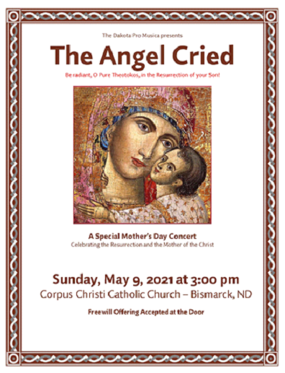

ST. GEORGE’S ANNOUNCEMENTS
We need your help updating ALL congregational information!

There is a PRINTED LIST in the Narthex with some of the information we need for our church records. PLEASE review your information, update the information so it’s current and initial it so we know you’ve reviewed it. This list will be placed on the table for a few Sundays in May. Initial by your name when changes are edited please.

For church records, we need the following, please:
Full names of all family members and dates of birth for all
Physical home address, city, state and zip; Mailing address if different
Home phone number, and cell phone numbers
Email addresses for each family member (who uses one)
*Emergency Contact Information* (name and cell/phone numbers please)
Wedding anniversary, Ordination anniversary and any other important dates

*NOTE: You can email this information directly to the church office at: stgeorges@stgeorges-bismarck.org or call the office at 701.223.1942.
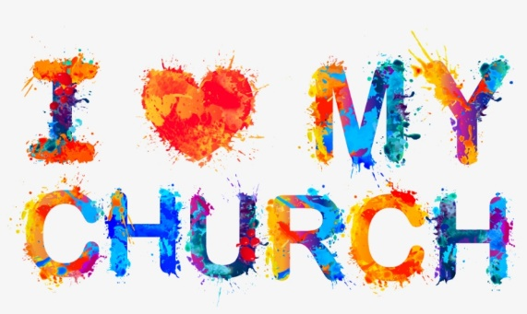

FRIENDLY REMINDER

PLEASE - If you use the back door, make sure BOTH locks are engaged with your key after you exit. The crash bar lock, and the deadbolt need to be engaged from the outside with your key. Thank you!

